**3K Course**

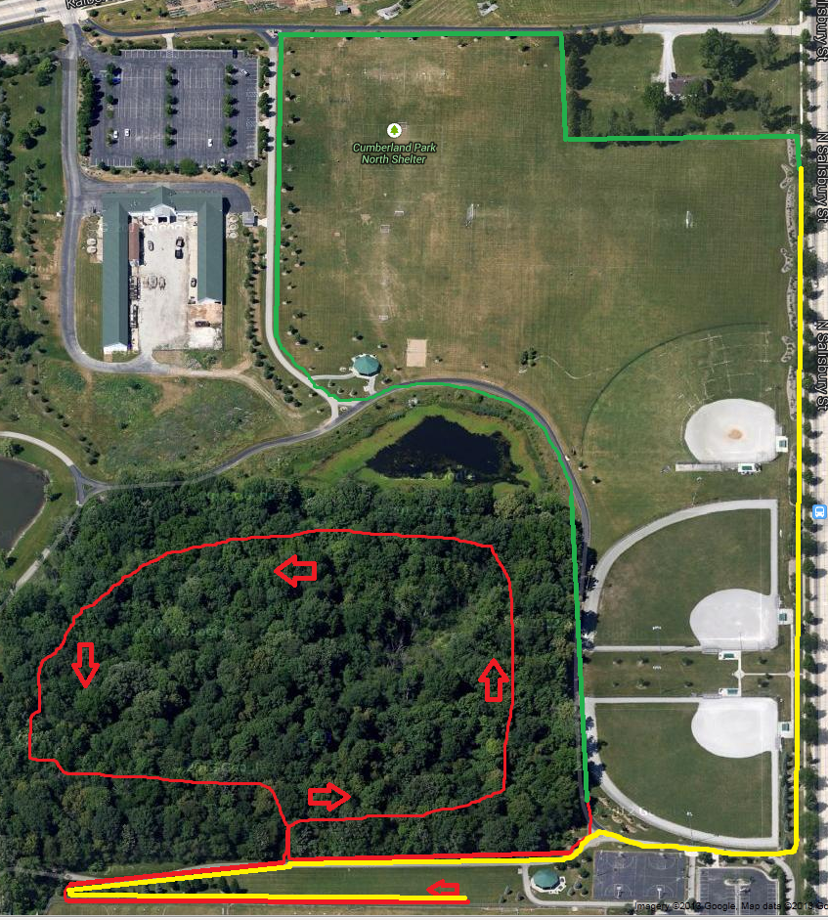

**3K Course**

**Red = 1K**

**Green = 2K**

**Yellow = 3K**